UCD School of Electrical, Electronic



& Communications Engineering

EEEN40010 Control Systems

Minor Project 2 Linear State Feedback And Observer Control Systems Report

*Fergal Lonergan 13456938*

**Declaration: I declare that the work described in this report was done by the person named above, and that the description and comments in this report are my own work, except where otherwise acknowledged. I have read and understand the consequences of plagiarism as discussed in the EECE School Policy on Plagiarism, the UCD Plagiarism Policy and the UCD Briefing Document on Academic Integrity and Plagiarism. I also understand the definition of plagiarism.**

Signed: _________________________________

Date: _________________________________

Minor Project 2 - Linear State Feedback And Observer

The plant is modelled by the following state space equation with input u and output y:

𝑥̇ = 𝐴𝑥 + 𝐵𝑢

𝑦 = 𝐶𝑥 + 𝐷𝑢

With matrices:

𝐴 = $\left[\begin{aligned}\begin{matrix}-0.9 & 4.6 & 0 \\ 0 & -2.9 & 1 \\ 0 & 0 & -0.87\end{matrix} \begin{matrix}0 \\ 0 \\ 0.52\end{matrix} \\ \begin{matrix}-17.9 & -6.5 \begin{matrix}-5.5 & -3.9\end{matrix}\end{matrix}\end{aligned}\right]$ 𝑆𝑡𝑎𝑡𝑒 𝑡𝑟𝑎𝑛𝑠𝑖𝑡𝑖𝑜𝑛 𝑚𝑎𝑡𝑟𝑖𝑥

𝐵 = $\left[\begin{aligned}1.1 \\ 0.2 \\ -0.1 \\ 1\end{aligned}\right]$ 𝐷𝑖𝑟𝑒𝑐𝑡 𝑓𝑒𝑒𝑑 𝑖𝑛 𝑚𝑎𝑡𝑟𝑖𝑥

𝐶 = $\left[1 0 0 0\right]$ 𝑅𝑒𝑎𝑑𝑜𝑢𝑡 𝑚𝑎𝑡𝑟𝑖𝑥

𝐷 = $[0]$ 𝐷𝑖𝑟𝑒𝑐𝑡 𝑓𝑒𝑒𝑑𝑡ℎ𝑟𝑜𝑢𝑔ℎ matrix

As the state space matrix is a 4x4 matrix we note that the order of the plant is n=4.

Now examining this further I can find that the poles and zeros of the system are as follows:

Poles of system:

−0.365 + 1.8j

−0.365 − 1.8j

−3.92 + 1.58j

−3.92 − 1.58j

Two pairs of complex conjugate poles.

Zeros of system:

−1.89 + 1.48j

−1.89 − 1.48j

−4.72

One real zero at 4.72 and one pair of complex conjugate zeros.

We know that for a plant to be pen-loop stable all poles of the plant must lie in the left half plane (LHP). This is the case with our plant.

Furthermore as no zeroes lie in the right half plane (RHP), there are no minimum phase zeros.

We can now formulate the transfer function of the plant:

𝐺𝑝 = $\frac{1.1s^{3} + 9.357s^{2} + 26.02s + 30.02}{s^{4} + 8.57s^{3} + 26.99s^{2} + 39.59s + 60.5}$

Now to check if the plant is completely controllable I will check the controllability matrix’s rank and determinant.

$$Γ = [ B, A × B, A^{2} × B, A^{3}× B]$$

Γ = $\left[\begin{aligned}\begin{matrix} 1.1 & -0.07 & -3.1 \\ 0.2 & -0.68 & 2.57 \\ -0.1 & -0.61 & -12.78\end{matrix} \begin{matrix} 14.62 \\ -20.26 \\ 60.11\end{matrix} \\ \begin{matrix}1 & -23.57 \begin{matrix} 94.2 & -261.14\end{matrix}\end{matrix}\end{aligned}\right]$

det(Γ) = 3.6 × ${10}^{3}$

We note that as the determinant of the controllability matrix is non-zero and the rank of the controllability matrix is 4, i.e. non-singular, the plant is completely controllable.

I will now check the rank of the observability matrix to see if the plant is fully observable:

$Γ_{0}$ = $\left[\begin{aligned}C \\ CA \\ CA^{2} \\ CA^{3} \end{aligned}\right]$

$$Γ_{0}=\left[\begin{aligned}\begin{matrix} 1 & 0 & 0 \\ -0.9 & 4.6 & 0 \\ 0.81 & -17.48 & 4.6\end{matrix} \begin{matrix}0 \\ 0 \\ 0\end{matrix} \\ \begin{matrix}-0.72 & 54.41\begin{matrix} -21.48 & 2.392\end{matrix}\end{matrix}\end{aligned}\right]$$

𝑟𝑎𝑛𝑘 ($Γ_{0}$) = 4

As we can observe all states of the observability matrix we can state that the plant is completely observable. The observability matrix also has a rank of 4, i.e. non-singular, which validates our case.

# Linear State Feedback Controller, Preamplifier and Observer

We were given the following specifications for our controller:

1. Zero SSE to step input
2. (ii) Percentage overshoot not exceeding 20%
3. (iii) 2% settling time not exceeding 4 sec

We note that there are 4 poles in our system, therefore it is required that there be a dominant pair of conjugate poles in order to locate the poles of the controller. Using the percentage overshoot formula I can find my damping ratio $ζ$:

$$100e^{ -\frac{πζ}{\sqrt{\left(1-ζ^{2}\right)}} } ≤ 20,$$

$$ζ ≥ 0.455$$

I can now use this and the formula for my 2% settling time to find a value for $ω_{n}$, the natural frequency of the system:

$$\frac{4}{ζω_{n}} < 4$$

$$ω_{n} > 2.19 rad/sec$$

Therefore my natural frequency can be chosen as 2.2 rad/sec.

Now using the following quadratic and subbing in our newly found variables we can determine the values of our dominant complex conjugate pair of poles:

$$s^{2} + 2ζωns + ω_{n}^{2} = s^{2} + 2.002s + 4.84$$

The poles are ∶

−1 + 1.96j

−1 − 1.96j

As the dominant pair have real parts of -1, which is quite close to the imaginary axis, the third and fourth pole of the system must have real parts much less than this. I chose to have two real poles at -4 and -5 as I found these were sufficiently far enough into the LHP without being un-realistic.

I then determined the following gain matrix, K, in order to achieve these closed loop poles:

𝐾 = [1.4936, 3.1294, −0.6318, 0.1]

Therefore the closed loop transfer function with ideal step input of my plant is as follows:

𝐺𝑝 = $\frac{1.1s^{3} + 9.357s^{2} + 26.02s + 30.02}{s^{4} + 11s^{3} + 42.86s^{2} + 83.6s + 96.8}$

Analyzing this I get the following poles, as required:

−5 + 0j

−4 + 0j

−1 + 1.96j

−1 − 1.96j

Plotting the step response of the closed loop step response I get:

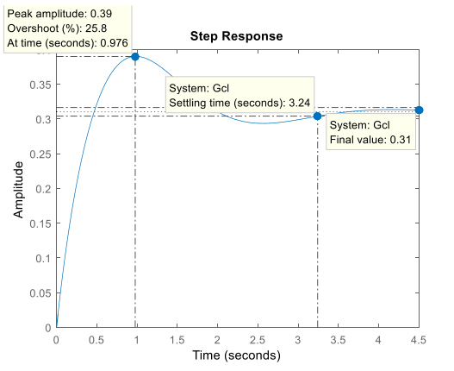

We note that unfortunately this does not meet the specifications of our design. Our overshoot is quite large exceeding the quite generous 20% allowed to us in the specifications. I am also not happy with my steady state value as the zero-steady state error is definitely not met as the value is 0.31, however my 2% settling time is within the specifications of 4 seconds.

I decide to vary my gain values to see if this would help improve my response. I found by varying the smallest gain of 0.1 I could achieve a more desirable step response. The following graph shows my step response when I changed $K_{4}$ to 0.1, 0.08, 0.05 and then to -0.4

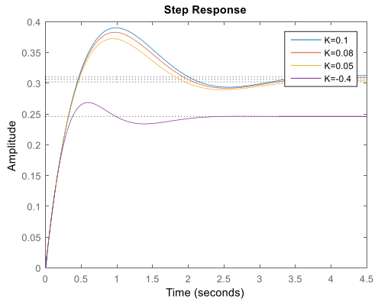

It is clear to see that the responses improve with decreasing $K_{4}$ and that -0.4 returns by far the best response shape. Our percentage overshoot has reduced drastically to 9.13% and our 2% settling time is now a much more respectable 1.91seconds than when we used the previous gain of 0.1. I found that K=-0.4 gave a significantly better PO% (9.13%) and 2% settling time (1.91 sec) than the previous gain of 0.1, so this gain was used before adding the preamplifier.

As we note that tracking cannot be achieved, and our steady state input is well below the zero error we desire, we add in a preamplifier $\overline{N}$ that will scale our reference input and provide us with zero error tracking.

$$\overline{N} = -\frac{1}{C{\left(A - BK\right)}^{-1}B}$$

The resulting closed loop system is described by the following equations:

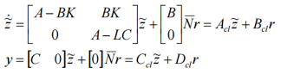

Where $B_{cl}$ is the reference input scaled by the preamplifier.

Therefore our new step response, including the newly added preamplifier is:

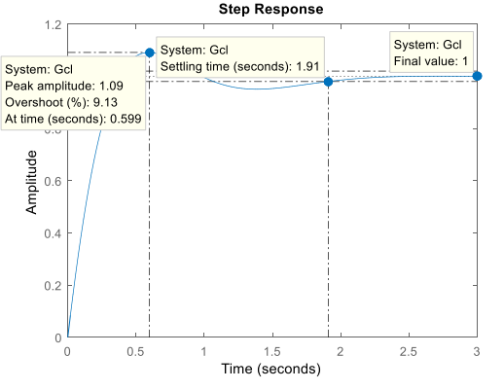

Immediately the first thing we notice is that our steady state error is now zero. Furthermore, as above our percentage overshoot remains at 9.13% and our 2% settling time is still 1.91seconds. Thus the design specifications have been met. However, the specifications also require an observer to achieve full-state linear feedback.

An observer works by giving an estimate of the remaining states in the system instead of measuring every single state. To do this it only measures the output. The Luenberger observer corrects the estimations of the states with feedback from the estimation error.

The observer is described by the following equations:

$$\dot{\hat{x}} = A\hat{x} + Be + L(y - \hat{y})$$

$$\hat{y} = C\hat{x}$$

The observer error is described by the expression:

$${\dot{e}}_{obs}\left(A - LC\right)e_{obs} , where e_{obs} = x - \hat{x}$$

To ensure the observer provides accurate readings of the states of the plant, we must choose appropriate eigenvalues for (A-LC). If we choose eigenvalues of (A-LC) far enough into the LHP the estimation error will converge to zero.

I decided to place the eigenvalues at [-100, -101, -102, -103] as after investigation I found that these values worked best.

Therefore L= [397.43, 12768.8, 84654, 37855435.3]

To ensure zero steady state error to the step input, I once again included $\overline{N}$. I also included the observer.

The final closed loop transfer function was

𝐺𝑐𝑙 =

$$\frac{4.47s^{7} + 1853s^{6} + 2.918e5s^{5} + 2109e7s^{4} + 6.4e8s^{3} + 4.48e9s^{2} + 1.173e10s + 1.3e10}{s^{8} + 416.5s^{7} + 6.613e4s^{6} + 4.85e6s^{5} + 1.532e8s^{4} + 1.333e9s^{3} + 5.87e{9s}^{2} + 1.367e10s + 1.294e10}$$

The step response of the closed loop system $G_{cl}$ with step input is as follows:

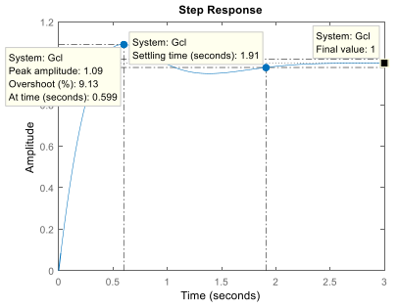

We note that the step response with the observer and the step response without the observer appear to provide the exact same graph. This is because the observer is measuring at such a high degree of accuracy that the relative observer’s estimation error is $≈$ 0.

# PID Controller (Root Locus):

To meet the specifications we can use a PID controller of the following form:

$$G_{c}\left(s\right)=\frac{k\left(s + z_{1} \right)\left(s + z_{2} \right)}{s + p}$$

As our 2% settling time must be less than or equal to 4 seconds we can calculate $σ$ the location of our closed loop poles:

$$\frac{4}{σ} ≤ 4$$

$$1 ≤ σ$$

We now know that the closed loop poles must be to the left of -1 on our root locus, to ensure that the system responds fast enough. To achieve this in the closed loop system we must choose a suitable gain k. Zero steady state error is then achieved by placing a pole at 0.

To ensure our percentage overshoot does not exceed a value of 20% we must choose a suitable sector angle using the formulae below:

𝑑𝑎𝑚𝑝𝑖𝑛𝑔 𝑟𝑎𝑡𝑖𝑜 ζ, $100e^{ –πζ \sqrt{1-ζ^{2}} } ≤ 20,$

$$ζ ≥ 0.455$$

s𝑒𝑐𝑡𝑜𝑟 𝑎𝑛𝑔𝑙𝑒 𝜙, $ϕ = \tan^{-1} \left(\frac{\sqrt{1 - ζ^{2}}}{ζ}\right)$

𝜙 = 64.8°

Now plotting the root locus of our system we get:

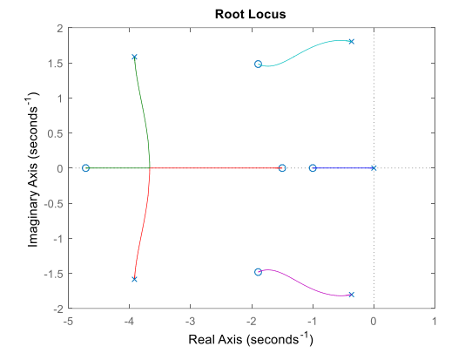

Zeroes have been introduced to the left of -1 at -1.5 and -4.8. This will improve the speed of our systems response. I then chose to place my $z_{1}$ and $z_{2}$ the left of -1, which is also to the left of my complex pole pair at -0.38, which will ensure the closed loop poles will lie in the correct region once I introduce my gain k. After some experimentation I found that $z_{1}=-2 and z_{2}=-3$ work appropriately. I then determined a suitable controller gain using rlocfind. Following this I chose my gain to be 1.

I then plot the step response of my closed loop system with my new controller and an ideal stepped input:

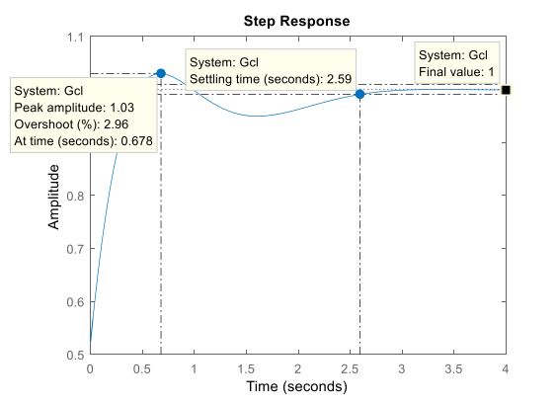

We note that all the specifications are met with the controller having zero steady state error, a 2% settling time of approximately 2.6 seconds, below the 4 seconds of our specifications, and a percentage overshoot of approximately 3% well below the 20% specified.

# PID Controller (Frequency)

As I now know a PID controller works I again used this controller type.

Once again we are required to have a percentage overshoot less than or equal to 20%. We can use this to obtain a damping ratio, $ζ$:

$$100e^{\left(-πζ \sqrt{1-ζ^{2}}\right)}≤ 20$$

$$ζ ≥ 0.46$$

Phase margin $≥46°$

Making the assumption that the resultant closed loop system has a dominant pair, our settling time must be less than 4 seconds. Using this we can find our natural frequency, $ω_{n}$, and then use that to find our gain crossover frequency, $ω_{gc}$:

$$ts\left(2\%\right)< 4\sec{}$$

$$so\frac{4}{0.46ω_{n}} < 4 ω_{n} > 2.17 rad/sec$$

$$ω_{gc} = ω_{n}\sqrt{\sqrt{1+ 4ζ^{4}} - 2ζ^{2}} ≅ 1.776$$

I chose to have a gain crossover frequency, $ω_{gc},$ of 3 rad/sec.

At 3rad/second the plant has a gain of -6.4dB and a phase of -90 $°$. The gain of the controller therefore must be 6.4dB at 3rad/ to ensure that the gain crossover frequency occurs at this point. I chose the phase margin of the controller to be 60°.

$$Phase controller + Phase plant\left(-90°\right)≥ -180° + 60° Phase controller ≥ -30 G_{c}\left(j3\right)=\frac{\left(z_{1}+ 3j \right)\left(z_{2}+ 3j \right)}{3j}$$

$$\left(z_{1}+ 3j\right)\left(z_{2}+ 3j\right)> 90° - 30°=60°$$

So the combined phase of our zeros, $z_{1}$ and $z_{2}$, must be greater than 60°. I chose $z_{1}$ to give a phase of 45° and $z_{2}$ to give a phase of 30°

$$\tan^{-1}{\frac{3}{z_{1}}}= 45°$$

$$\tan^{-1}{\frac{3}{z_{2}}}=30°$$

$$z_{1}=3 , z_{2}=5$$

Now to find an appropriate gain, k:

$$20log10k + 20log10\frac{\left(3+ 3j\right)\left(5+ 3j \right)}{3j} = 6.4dB$$

$$20log10k + 18.44 = 6.41 k = 0.25$$

Therefore the controller’s transfer function is:

$$G_{c}\left(s\right)=\frac{0.25\left(s + 3\right)\left(s + 5\right)}{s}$$

The closed loop step response due to an ideal step input with this PID controller is:

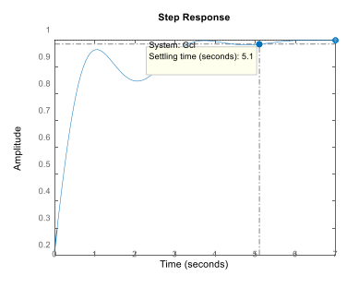

However it is clear that the settling time is too long so I tuned the gains of the system.

The following is the step response of the close loop system for the following gains:

$$k_{p} = 10, k_{d} = 0.25, k_{i} = 20$$

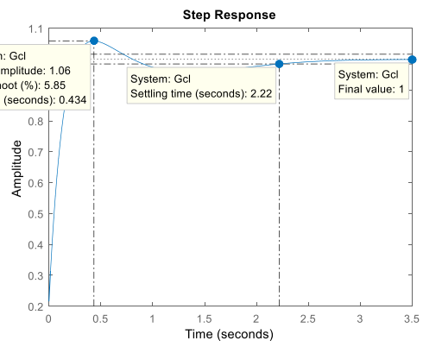

We see now that all the specifications are met. I.e. zero steady state error, a settling time below 4 seconds and a percentage overshoot of below 6%

# Robustness of Linear State Feedback with Luenberger Observer:

By altering the values of the state transition matrix and the direct feed-in matrix, we can test the Leunberger Observer’s robustness.

𝐴 = $\left[\begin{aligned}\begin{matrix}-0.9 & 4.6 & 0 \\ 0 & -2.9 & 1 \\ 0 & 0 & -0.87\end{matrix} \begin{matrix}0 \\ 0 \\ 0.52\end{matrix} \\ \begin{matrix}-17.9 & -6.5 \begin{matrix}-5.5 & -3.9\end{matrix}\end{matrix}\end{aligned}\right]$ 𝑆𝑡𝑎𝑡𝑒 𝑡𝑟𝑎𝑛𝑠𝑖𝑡𝑖𝑜𝑛 𝑚𝑎𝑡𝑟𝑖𝑥

𝐵 = $\left[\begin{aligned}1.1 \\ 0.2 \\ -0.1 \\ 1\end{aligned}\right]$ 𝐷𝑖𝑟𝑒𝑐𝑡 𝑓𝑒𝑒𝑑 𝑖𝑛 𝑚𝑎𝑡𝑟𝑖𝑥

If we try alter the matrices slightly changing the following values:

A (1, 1) =-0.8, A (4, 2) =-5.5

𝐴 = $\left[\begin{aligned}\begin{matrix}-0.8 & 4.6 & 0 \\ 0 & -2.9 & 1 \\ 0 & 0 & -0.87\end{matrix} \begin{matrix}0 \\ 0 \\ 0.52\end{matrix} \\ \begin{matrix}-17.9 & -5.5 \begin{matrix}-5.5 & -3.9\end{matrix}\end{matrix}\end{aligned}\right]$ 𝑆𝑡𝑎𝑡𝑒 𝑡𝑟𝑎𝑛𝑠𝑖𝑡𝑖𝑜𝑛 𝑚𝑎𝑡𝑟𝑖𝑥

B (2) =0.1

𝐵 = $\left[\begin{aligned}1.1 \\ 0.1 \\ -0.1 \\ 1\end{aligned}\right]$ 𝐷𝑖𝑟𝑒𝑐𝑡 𝑓𝑒𝑒𝑑 𝑖𝑛 𝑚𝑎𝑡𝑟𝑖𝑥

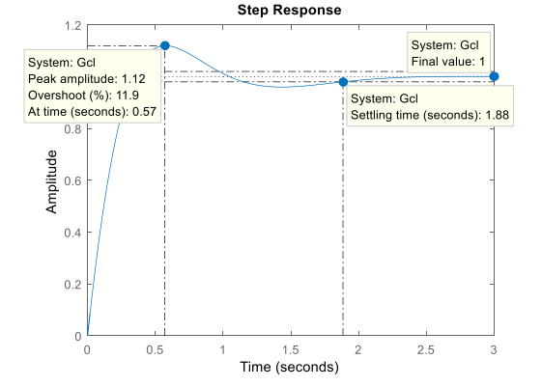

We see that the settling time has reduced however the percentage overshoot has grown. We still have zero steady state error however which is expected.

The system fails to meet the specifications for our controller if we reduce both our state transition matrix and direct feed-in matrix by a value of 10%.

𝐴*0.9 = $\left[\begin{aligned}\begin{matrix}-0.9 & 4.6 & 0 \\ 0 & -2.9 & 1 \\ 0 & 0 & -0.87\end{matrix} \begin{matrix}0 \\ 0 \\ 0.52\end{matrix} \\ \begin{matrix}-17.9 & -6.5 \begin{matrix}-5.5 & -3.9\end{matrix}\end{matrix}\end{aligned}\right]$*0.9 𝑆𝑡𝑎𝑡𝑒 𝑡𝑟𝑎𝑛𝑠𝑖𝑡𝑖𝑜𝑛 𝑚𝑎𝑡𝑟𝑖𝑥

𝐵*0.9 = $\left[\begin{aligned}1.1 \\ 0.2 \\ -0.1 \\ 1\end{aligned}\right]$*0.9 𝐷𝑖𝑟𝑒𝑐𝑡 𝑓𝑒𝑒𝑑 𝑖𝑛 𝑚𝑎𝑡𝑟𝑖𝑥

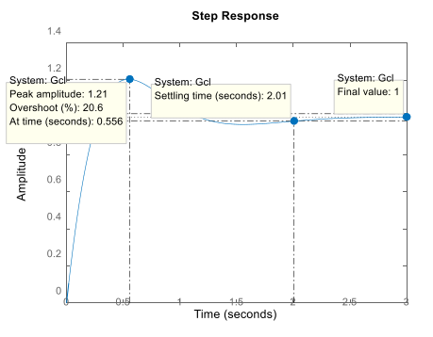

We note now that the value for our percentage overshoot has been exceeded as it is now greater than 20%.

We exceed our settling time criteria if we increase our state transition matrix and direct feed-in matric by 20%:

𝐴*1.2 = $\left[\begin{aligned}\begin{matrix}-0.9 & 4.6 & 0 \\ 0 & -2.9 & 1 \\ 0 & 0 & -0.87\end{matrix} \begin{matrix}0 \\ 0 \\ 0.52\end{matrix} \\ \begin{matrix}-17.9 & -6.5 \begin{matrix}-5.5 & -3.9\end{matrix}\end{matrix}\end{aligned}\right]$*1.2 𝑆𝑡𝑎𝑡𝑒 𝑡𝑟𝑎𝑛𝑠𝑖𝑡𝑖𝑜𝑛 𝑚𝑎𝑡𝑟𝑖𝑥

𝐵*1.2 = $\left[\begin{aligned}1.1 \\ 0.2 \\ -0.1 \\ 1\end{aligned}\right]$*1.2 𝐷𝑖𝑟𝑒𝑐𝑡 𝑓𝑒𝑒𝑑 𝑖𝑛 𝑚𝑎𝑡𝑟𝑖𝑥

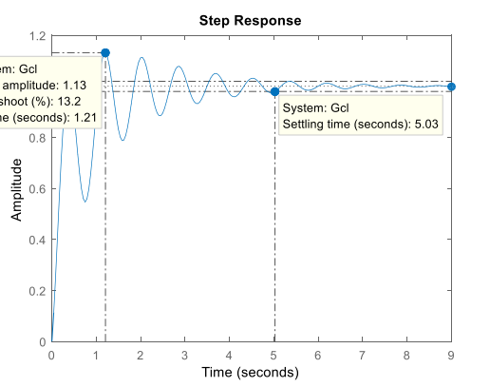

The closed loop system begins to ring and also the steady state value is now at around 5 seconds, greater than the 4 seconds we had planned for.

Therefore it is clear that if the model parameters of the state transition matrix or direct feed-in matrix are varied by a significant amount the linear state feedback with Luenberger observer control system may begin to exceed the specifications. If the variance is small enough, say ± 5%, the system should meet the specifications.